Chapter 3
Project Planning and Scheduling
Project Planning
- A plan is a listing or visual display that results when all project activities have been subjected to estimation, logical sequencing and time analysis.
- Some form of network analysis is usually the preferred method for preparing a plan.
- However, some charting methods provide better visual aids and can be more effective for communicating plans to project personnel.
Project Planning
Project planning determines a project schedule based on:
- Project constraints e.g. delivery, staff and Budget.
- Project parameters e.g. structure, size and functions.
- Project milestones and deliverables.
Project planning and scheduling must estimate the risk associated with each decision.
Scheduling involves separating work into tasks and predicting task completion.
The schedule must be revised periodically with progress.
Types of Project plans
Quality plan: This describes the quality procedures and standards that will be used in the project.
Validation plan: Describes the approach, resources and schedule used for system validation.
Configuration management plan: Describes the configuration management procedures and structures to be used.
Maintenance plan: Predicts the maintenance requirements of the system, maintenance cost and effort required.
Staff development plan: This describes how the skills and the experience of the project team members will be developed.
Work Breakdown Structure (WBS)
- A structure used to divide projects into manageable tasks.
- Creating a WBS requires that phases be decomposed into activities, and activities into tasks.
- Each task should be defined at the appropriate level of detail.
Work Breakdown Structure (WBS)
Some tasks may be performed in parallel while others must follow one another sequentially.
Task sequence depends on the following:
- Which tasks produces deliverables needed into other tasks.
- Constraints placed on the project by client.
- Process outlined in the development life cycle.
Guidelines for Defining a Task
A task should:
- Be done by one person or a well-defined group.
- Have a single and identifiable deliverable.
- Have a known method of technique.
- Have a well-accepted predecessor and successor steps.
- Be measurable so that percentage completed can be determined.
Advantages of WBS
- It reduces the complexity of the project since a large or complicated project may be considered as a collection of small projects.
- It helps in resource allocation because different phases will require a different type of resources or skills.
- It helps in monitoring project progress because the completion of a phase may be regarded as a key milestone.
Sample Work Breakdown Structure
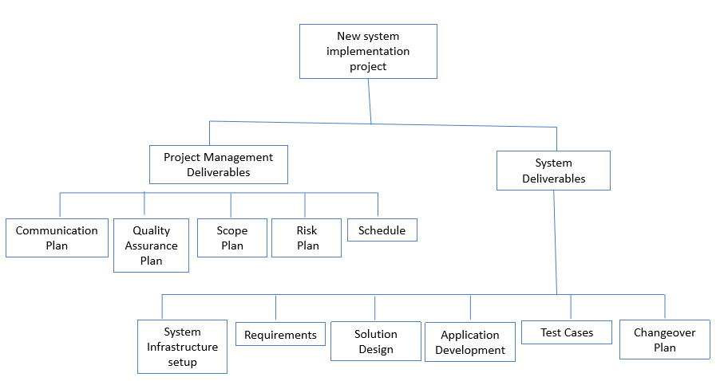

Gantt Charts
This is a visual representation of the project activities and their durations. The vertical axis represents the activities, and the horizontal axis represents the duration.
Example:
- The table in the next slide represents a software project specification with estimated project activity durations, and their precedence requirements. Draw a Gantt chart for the project.
Project specifications
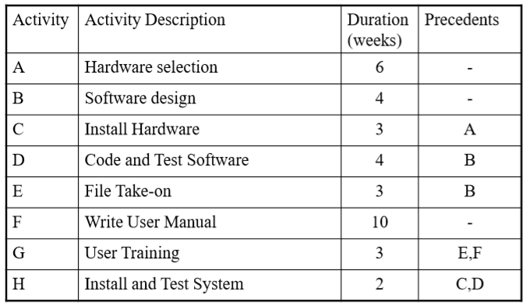
Gantt Chart for the Project
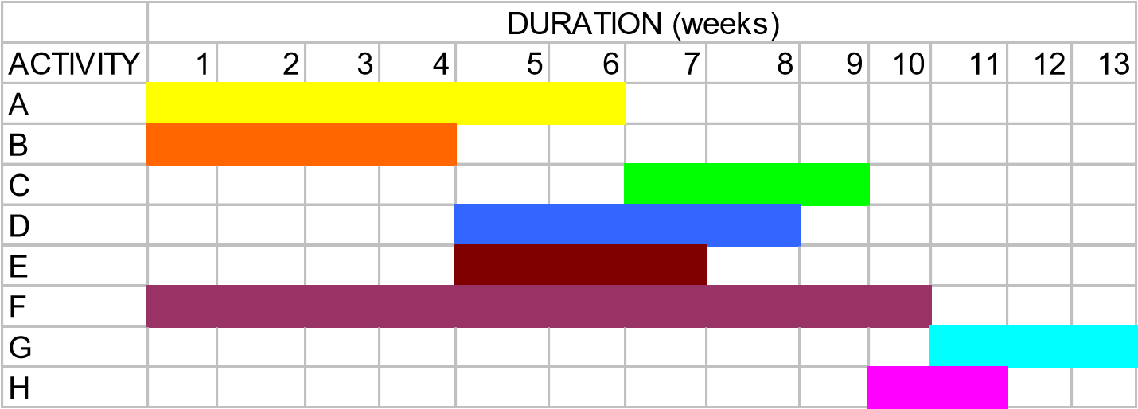
Estimated Project Duration = 13 Weeks
Note: One can use different styles, shades for the duration.
Network Analysis Diagrams
Two types:
- Activity-on-Arrow (AoA) Diagrams.
- Activity-on-Node (AoN) Diagrams.
Activity-on-Arrow (AoA) Diagrams
The diagram represents activities by links or arrows and the nodes represents events of activities as groups of activities start or finishing.
Rules and conventions are:
- A project network diagrams may have only one start node.
- Project network diagram may have only one end-node.
- A link has duration.
AoA Rules
- Nodes have no duration. Nodes are events and are therefore instantaneous points in time.
- The source node is the event of the project becoming ready to start and the sink node is the event of the project becoming completed.
- Intermediate nodes represents 2 simultaneous events i.e.. The event of all activities leading into a node having been completed, and the event of all activities leading out of those nodes being in a position to be started.
Rules and Conventions for AoA
- Time moves from left to right.
- Nodes are numbered sequentially.
- A network may not contain loops.
- A network may not contain dangles.
Activity-on-Arrow Diagram
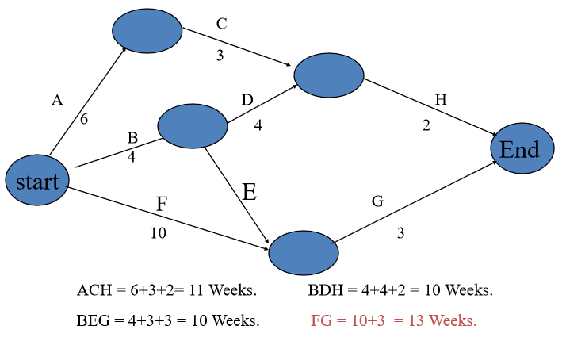

Activity-on-Node diagrams
- The arrows represent the event and the node represent the activity.
- The meaning of arrows and the nodes are directly opposite to that of Activity-on-Arrow diagrams.
- Project Evaluation and Review Technique (PERT) and Critical Path Modeling are two popular quantitative analysis techniques that are used with the AoN diagrams.
- These techniques help managers to plan, schedule, monitor and control large and complex projects.
- The critical path consists of the activities that are important and their delay will affect the entire project completion time.
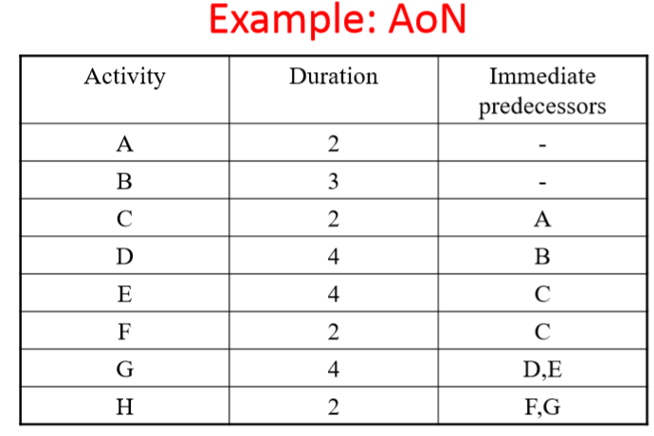
AoN Diagram
FINISH
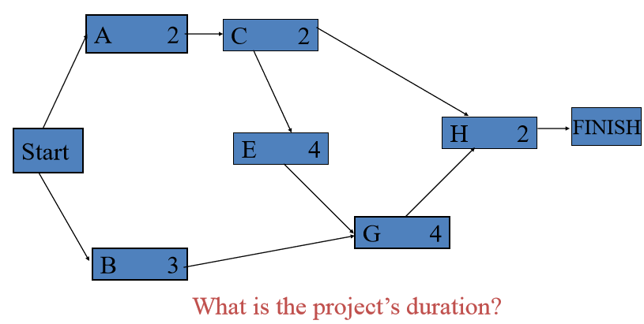

New and/or Unique Projects
- For new or unique projects, providing activity time estimates is not always easy.
- Without solid historical data, project managers are usually uncertain on the activity times.
- For this reason, the developers of PERT employed a probability distribution based on the following time estimates:
  - Optimistic time (a).
  - Pessimistic time (b).
  - Most-likely time (m).
  - Expected activity time (t).
  - variance
Time Estimates
Optimistic Time (a): this is the time that an activity will take if everything goes as well as possible.
Pessimistic Time (b): The time an activity would take assuming very unfavourable conditions.
Most-Likely Time (m): Most realistic time estimate to complete the activity.
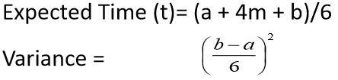
Finding the Critical Path
- Path refers to a series of connected activities ( or intermediate events) between two events in a network.
- Critical path refers to the set of activities on a path from the project’s start event to its finish event, if delayed, will delay the completion date of the project.
- Once the expected completion time for each activity ha been determined, it is accepted as the actual time of the task.
- To find the critical path, the following times are calculated for each activity:
  - Earliest start/event time (ES).
  - Earliest Finish Time (EF).
  - Latest start time (LS).
  - Latest finish time (LF).
Calculating Earliest Activity Times:
- Forward Pass
- Earliest Start time is the earliest time an activity can begin without violation of immediate predecessor requirements.
- ES = largest of the earliest finish times of immediate predecessors
- Earliest Finish Time is the earliest time an activity can end.
- EF = Earliest start time + expected activity time = ES + t.
- Before any activity can begin, all of its predecessor activities must be completed i.e. the largest EF for all of the immediate predecessor, used in determining ES.
- Backward/Reverse Pass
- Latest Start Time is the latest time an activity an begin without delaying the entire project.
  - LS = latest finish time – activity time
  - LS = LF – t
- Since all immediate predecessors must be finished before an activity can begin, the latest start time for an activity determines the latest Finish time for its immediate predecessors.
- Latest Finish time is the latest time an activity can end without delaying the entire project.
- LF = smallest of latest start times for following activities.
Notation
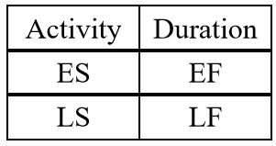 | 